Remote repository:
Remote repository providers.
GitHub
GitLab
Bitbucket
AWS,
Azure
Google cloud etc

Push the code from local machine to remote machine.
Steps
- Create the remote repository in git hub account.
- In local machine create folder.
- Then create any type of file with sample contents.
- Then open the command prompt or terminal inside a folder.
- git init
- git add .
- git commit -m “commit message”
- git branch -M main
- git remote add origin URL
- git push -u origin branchName

if you do any changes in local repository repeat below command to push new changes in remote repository
- git add .
- git commit -m “new commit message”
- git push -u origin main

if you want to download any public repository in your local machine
open the command inside a folder
git clone URL
next time you need any new changes to download in existing clone repository
move inside repository folder using cd or any other way.
git pull

To download public repository from github into local machine you need to execute below command
git clone URL : it download public repository in local machine.
Clone is use to download fresh copy into local machine.

git pull : it pull new changes done in remote repository to local machine.
This command must be executed inside clone repository.

If you want to do any changes in clone repository. Don’t do inside main or master branch(default branch). Create user defined branch using below command
Your command prompt inside hello_repository
Create the branch
git branch branchName
git checkout branchName
do some modification in any file and add and commit.

If you want to get new changes in clones repository. Switch to main or master branch and git pull
(changes in user defined branch and pull must be master or main branch).

If you want to get new updated from remote repository. You need to switch to main branch using command as
git checkout main
git pull

git pull vs git fetch
git pull it pull new updates from remote to local and merge the code in local repository.
But git fetch it pull only doesn’t merge to local repository.

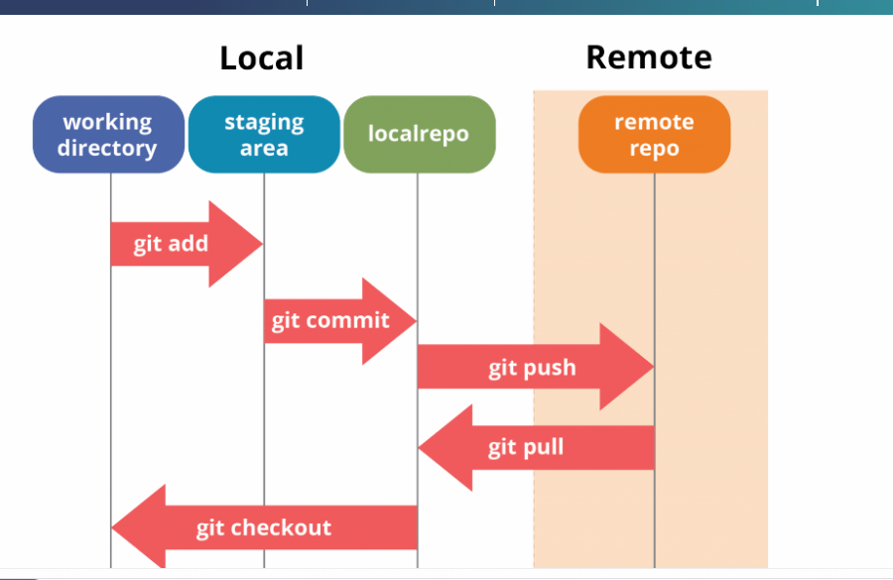

git commit -m “commit message”

git provide unique id for each commit. Using that commit id we can move from one pointer to another pointer. Like undo or re-undo

to check all commit details in particular branch

git log

HEAD which refer to last commit.

git reset --hard commitId

get the contents from deleted branch

creating and switch in new user defined branch you can run below command
git checkout -b feature_branch

git reflog : it show all actions details like checkout, delete, commit etc.

using below command you can revert back deleted branch code in temporary branch

git checkout -b temp_features_branch ea8db26
temp_features_branch new branch to hold deleted branch code
ea8db26 action id which we retrieve using git reflog

